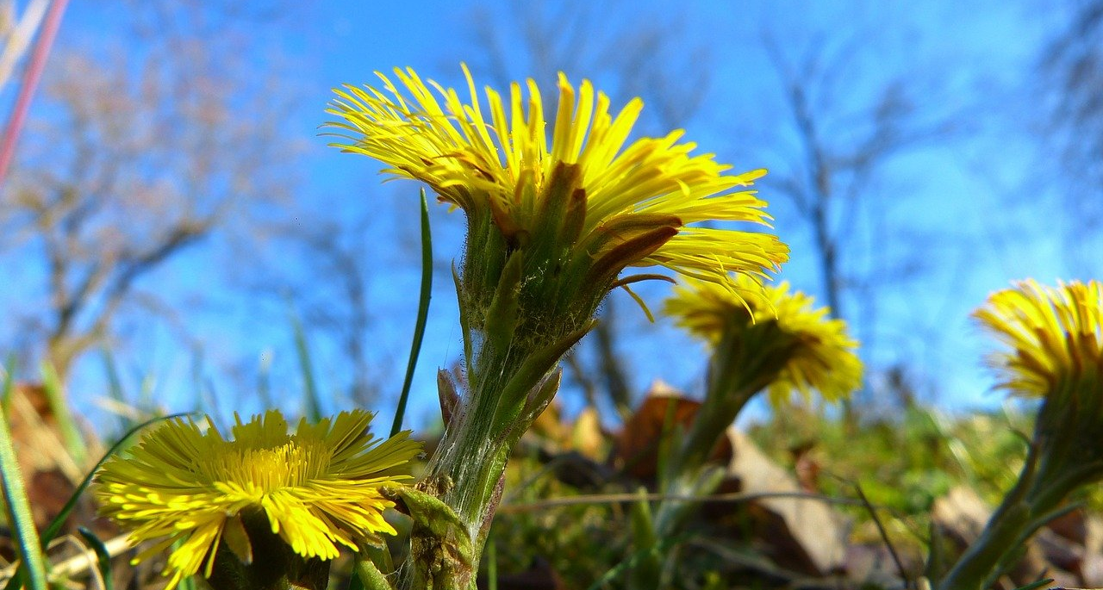

My Everyday life – what is it like? Tell us!

Dear resident of Pyhäjoki, what is fine in your everyday life? What worries you or what would you wish to change? What would make your worries go away?

We wish to help the residents of our municipality to lead a good everyday life. To support our work, we need answers for the kind of questions above. For us to be able to help you, please help us by answering this survey:

https://link.webropol.com/s/mylife-mittliv

The survey is now open. We are grateful for every answer!

The survey will close May 29th 2021. When we report the results at a later date, we will make sure that you cannot be identified from your answers.

The survey will be conducted simultaneously in 28 municipalities in Northern Ostrobothnia.

Kind regards
The municipality of Pyhäjoki and the POPsote project in charge of promoting the health and social services reform in Northern Ostrobothnia

